Healthy-Steps Instructor Certification Program

Healthy-Steps, Moving you to better health with the Lebed Method, offers a wellness program for everyone from young adults to seniors, regardless of health, age or ability level. The program helps with improving range of motion, upper body mobility, decrease of lymphedema, improved posture, elevated self-esteem, decrease depression, increased flexibility, and improved quality of life. This introductory level training is currently being presented on Zoom, dates to be arranged with interested persons. The instructors are either Trainers or Master Trainers of the program. There are no prerequisites for taking the workshop, but passing the workshop (which includes a practical and a written exam) and having valid CPR certification are required prior to obtaining certification to become an instructor. The objectives of the training are:
- Identify the physiology of lymphedema as it pertains to Breast Cancer and the immune system
- Identify appropriate exercise interventions for lymphedema.
- Explain the importance of compression garments.
- Choose specific exercises that can be done sitting or standing to address commonly found issues in persons with chronic conditions
- Arrange a variety of exercise routines to music for group of persons with chronic conditions
- Demonstrate the Healthy-Steps Lymphatic opening movements.
- Explain the physiological effect of music on the body and mind.
- Be able to lead a Healthy-Steps exercise group program using commonly accepted precautions for persons with assorted chronic conditions.

The topics covered include a sample Healthy-Steps/Lebed Method class presented by the instructor, power points on lymphedema and precautions to take with persons with chronic condition, guidelines of the program, demonstration first by leader then by participant of the mandated lymphatic opening exercises and 45 other approved movements, demonstration on the basics of choreography of the movements for maximum benefit, leader led demonstration on how to choose music and how to lead a class, and discussion on how to market the program.
Currently Instructor Training is being conducted on Zoom over a period of approximately 16 hours. Sound and camera must always be on during the training. It can be done in small groups or individually and scheduled to accommodate your availability. It should be done on a minimum of 3 separate days, not necessarily consecutive days. The target audience consists of persons who work with Cancer survivors and/or persons with other chronic conditions. Special needs accommodation of attendees can be discussed at the time of registration.
The current cost of the Healthy-Steps group instructor training is $400 which includes the instruction, all the reference material and the first year of certification. Discounts are given if multiple persons enroll from one location. An annual fee of $100 (current rate reduced during COVID from previous $175) and 10 CEUs are required to maintain certification. Payment for the instructor sessions must be received prior to shipping the material. If you need to cancel after receipt of the material, credit will be issued for a future training. If the trainer needs to cancel and a mutually future date can’t be arranged, a full refund less $75 for material sent will be issued. If you are a lymphedema specialist and wish to use this program with your clients one-on-one as part of their treatment, please contact me for training information and applicable cost.

Contact Bonnie Vermillion, Master Trainer and presenter at bonnried@comcast.net or 540-547-4824 if you have questions or want to register for the Healthy-Steps Instructor training.

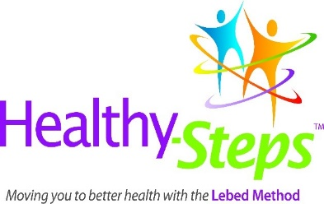
Healthy-Steps Instructor Certification 2024

This training is approved for Continuing Education credits (CEUs or CECs) by

The American Occupational Therapy Association, Inc (AOTA)
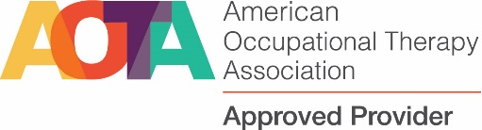
Lebed Method dba Healthy-Steps is an AOTA Approved Provider of professional development. PD activity approval ID#6261. The Live and distant learning have been approved for 1.5 CEUs (15 hours), for level 1 of category 3. Approval number 6261. The assignment of AOTA CEUs does not imply endorsement of specific course content, products, or clinical procedures by AOTA or indicate AOTA approval of a certification or other professional recognition.

National Certification Healthy Steps Certification Training NCCAP500519-24NT
Council For Activity For 20.5 instructional hours
Professionals (NCCAP)

