Posted: Tuesday, August 16, 2016 9:14 am
By MELISSA ST. AUDE, Staff Writer
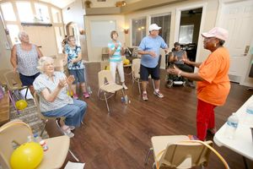
CASA GRANDE, There’s plenty of toe-tapping aerobic movement in Gwen Traylor’s therapeutic exercise class

Exercise class helps survivors get moving

Previous Next

Oscar Perez/Dispatch

Cypress Pointe apt.
Gwen Traylor instructs an exercise class for cancer patients/survivors Monday at Cypress Pointe apartments.
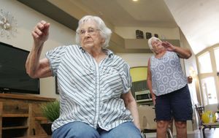
With a class aimed at helping cancer survivors recover and rebuild strength after surgery, a session with Traylor blends aerobic exercise with bubbles, hula hoops, stress balls and plenty of laughter and encouragement. “We have a good time,” said Traylor, who has survived two bouts with breast cancer and is certified as an
instructor for the Healthy Steps with the Lebed Method exercise program.
“There’s a lot of laughter and humor in the class,” she said.
Healthy Steps with the Lebed Method is a focus-on-the-healing movement and exercise routine designed to help cancer survivors recover physically and emotionally.

The routine includes gentle movements, fun music and positive reinforcement that empowers patients and improves the flow of the
lymphatic system, which is often impaired by surgery.

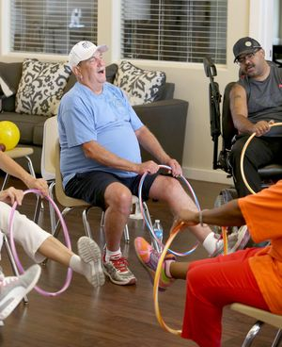
“It doesn’t look hard, but I feel the burn
in every class,” said David Johnson,
a student in Traylor’s weekly class at
Cypress Point retirement apartments.
“It’s exercise.”
Although it’s designed for cancer recovery, it’s
also good for other illnesses and chronic
conditions as well.

In Traylor’s class at Cypress Point, cancer survivors are joined by those with Huntington’s disease, arthritis and other conditions. Some are in wheelchairs.
The class is high energy, low impact and incorporates therapeutic movement, strength training and calorie-burning aerobic exercise, but there is no pressure for students to move too fast or keep up.
Traylor tells her students to press on if they can or take a break if necessary.
“The idea is to just keep moving,” Traylor said.
All exercises have modifications that allow them to be performed seated as well as standing. Those who can’t lift their arms completely over their heads also have modified movements.
Kathy Domke, a retired nurse, said she combines the exercise class with a fitness routine at an area gym to help her recover from breast cancer surgery.
“It’s a challenge getting your strength back up after surgery,” she said. “This class targets the muscles impacted by surgery and it’s fun.”
The Healthy Steps with the Lebed Method was designed by a former professional dancer who survived breast cancer. She created the program with her two brothers who were doctors.

Traylor discovered the program when she was recovering from breast cancer surgery several years ago.
The program got her moving and smiling again, she said.
“It helped me so much physically and emotionally,” she said. “Breast cancer surgery impacts strength and elasticity in the arms. This program helps with that.”
She became a certified instructor several years ago and said she enjoys seeing how the program helps people.

“We have patients who can barely walk without a cane or raise their arms above their chest when they first start,” she said. “I had one friend who soon after taking the class was wearing her high heels again.”
All class activities have a purpose, Traylor
said, even blowing bubbles.
“Blowing bubbles helps to open up the lungs
and gets us ready to exercise,” she said.
“Breathing exercises are so important.
It gives you energy.”
Traylor teaches one class a week at
Casa Grande at Cypress Point
retirement apartments.

It’s free to the residents of the complex but non-residents may join too for a small fee.
Traylor said she’d like to expand the class to other facilities throughout the community. She would also like to see other people in the community become certified instructors.
“In this community there is a real need for this program,” she said. “My goal is to help people be healthier and I’m blessed to have this life where I can help others.”
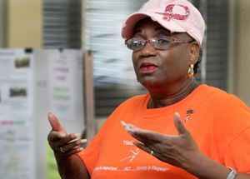
To learn more about joining the
class, becoming certified or
starting a class in a different
facility, send Traylor an email
at gwenhealthysteps@aol.com or
call her at 316-6761.
www.gohealthysteps.com

