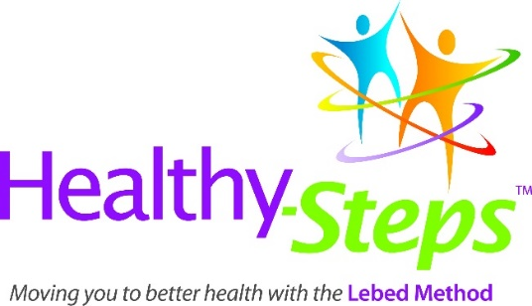

New Instructor Workshop

Contact bonnired@comcast.net if you want to enroll in a virtual
Healthy-Steps Instructor Workshop

